Housing Ombudsman urges zero tolerance approach on damp and mould

‘Spotlight on damp and mould - It’s not lifestyle’
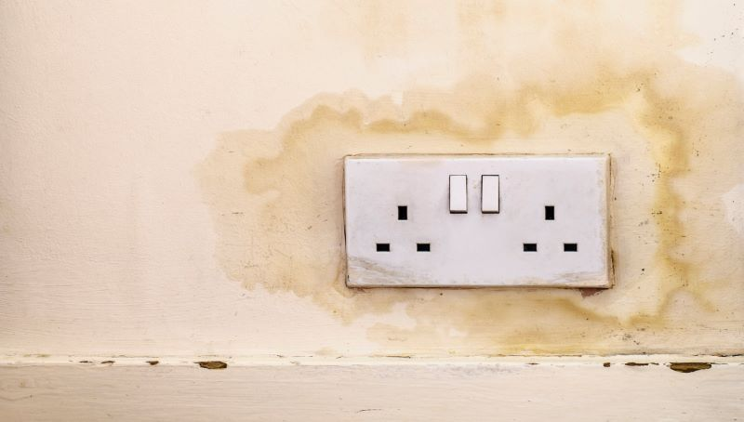
Social landlords should adopt a zero-tolerance approach to damp and mould says the Housing Ombudsman in a new report.
Addressing damp and mould needs to be a higher priority for landlords, states the report, with a change in culture from reactive to proactive in order to improve the experience of residents.
The report comes after an ITV News investigation lifted a lid on the scale of the problem in the social housing sector.
The Ombudsman’s report, ‘Spotlight on damp and mould - It’s not lifestyle’, examined 410 complaints investigated about 142 landlords over a two-year period, with maladministration found in 56%, rising to 64% for complaint handling alone.
As well as casework the report also draws on more than 500 responses to the Ombudsman’s call for evidence issued earlier this year. This failure rate was often the result of inaction, excessive delays or poor communication.
During its investigation, the Ombudsman found a general sense of frustration among residents, saying they felt they were not being heard or that their landlords were not taking their repair reports or complaints seriously.
The impact on residents was clear, with distress and inconvenience reported together with concerns about health and well-being.
The report recognises the challenges for landlords in tackling the issues – including overcrowding, poverty, the age and design of homes – but says landlords should avoid inferring blame on residents due to ‘lifestyle’, when it is often not solely their issue, and take responsibility for resolving problems.
In support of this, the report identifies best practice and makes 26 recommendations for landlords to implement:
- Landlords should adopt a zero-tolerance approach to damp and mould interventions. Landlords should review their current strategy and consider whether their approach will achieve this.
- Landlords should consider whether they require an overall framework, or policy, to address damp and mould which would cover each area where the landlord may be required to act. This would include any proactive interventions, its approach to diagnosis, actions it considers appropriate in different circumstances, effective communication and aftercare.
- Landlords should review the accessibility and use of their systems for reporting repairs and making complaints to ‘find their silence’.
- Landlords should identify opportunities for extending the scope of their diagnosis within buildings, for example by examining neighbouring properties, to ensure the response early on is as effective as possible.
- Landlords should implement a data driven, risk-based approach with respect to damp and mould. This will reduce over reliance on residents to report issues, help landlords identify hidden issues and support landlords to anticipate and prioritise interventions before a complaint or disrepair claim is made.
- Where properties are identified for future disposal or are within an area marked for regeneration, landlords should proactively satisfy themselves that residents do not receive a poorer standard of service or lower living conditions, that steps are taken to avoid homes degrading to an unacceptable condition and that they regularly engage and communicate with these residents.
- Landlords should avoid taking actions that solely place the onus on the resident. They should evaluate what mitigations they can put in place to support residents in cases where structural interventions are not appropriate and satisfy themselves they are taking all reasonable steps.
- Together with residents, landlords should review the information, materials and support provided to residents to ensure that these strike the right tone and are effective in helping residents to avoid damp and mould in their properties.
- Landlords should be more transparent with residents involved in mutual exchanges and make the most of every opportunity to identify and address damp and mould, including visits and void periods.
- Landlords should ensure their strategy for delivering net zero carbon homes considers and plans for how they can identify and respond to potential unintended consequences around damp and mould.
- Landlords should review, alongside residents, their initial response to reports of damp and mould to ensure they avoid automatically apportioning blame or using language that leaves residents feeling blamed.
- Landlords should consider their current approach to record keeping and satisfy themselves it is sufficiently accurate and robust. We would encourage landlords to go further and consider whether their record keeping systems and processes support a risk-based approach to damp and mould.
- Landlords should ensure that their responses to reports of damp and mould are timely and reflect the urgency of the issue.
- Landlords should review the number of missed appointments in relation to damp and mould cases and, depending on the outcome of any review, consider what steps may be required to reduce them.
- Landlords should ensure that their staff, whether in-house or contractors, have the ability to identify and report early signs of damp and mould.
- Landlords should take steps to identify and resolve any skills gaps they may have, ensuring their staff and contractors have appropriate expertise to properly diagnose and respond to reports of damp and mould.
- Landlords should ensure that they clearly and regularly communicate with their residents regarding actions taken or otherwise to resolve reports of damp and mould. Landlords should review and update any associated processes and policies accordingly.
- Landlords must ensure there is effective internal communication between their teams and departments, and ensure that one individual or team has overall responsibility for ensuring complaints or reports are resolved, including follow up or aftercare.
- Landlords should ensure that their complaints policy is effective and in line with the Complaint Handling Code, with clear compensation and redress guidance. Remedies should be commensurate to the distress and inconvenience caused to the resident, whilst recognising that each case is individual and should be considered on its own merits.
- Landlords need to ensure they can identify complex cases at an early stage, and have a strategy for keeping residents informed and effective resolution.
- Landlords should identify where an independent, mutually agreed and suitably qualified surveyor should be used, share the outcomes of all surveys and inspections with residents to help them understand the findings and be clear on next steps. Landlords should then act on accepted survey recommendations in a timely manner.
- Where extensive works may be required, landlords should consider the individual circumstances of the household, including any vulnerabilities, and whether or not it is appropriate to move resident(s) out of their home at an early stage.
- Landlords should promote the benefits of their complaints process and the Ombudsman to their residents as an appropriate and effective route to resolving disputes.
- Landlords should continue to use the complaints procedure when the preaction protocol has commenced and until legal proceedings have been issued to maximise the opportunities to resolve disputes outside of court. Landlords should ensure their approach is consistent with our jurisdiction guidance and their legal and complaint teams work together effectively where an issue is being pursued through the complaints process and protocol.
- Landlords should consider how best to share learning from complaints and the positive impact of changes made as a result within the organisation and externally. Systems should allow the landlord to analyse their complaints data effectively and identify themes, trends and learning opportunities.
- Landlords should ensure they treat residents reporting damp and mould with respect and empathy. The distress and inconvenience experienced by residents in this area is some of the most profound we have seen, and this needs to be reflected in the tone and approach of the complaint handling.
Richard Blakeway, Housing Ombudsman, said: “Throughout our investigation, the distress and disruption experienced by residents living with damp and mould was evident. These are conditions that no one working in social housing wants to see.
"Our high maladministration rate shows that a fairer approach is needed. A zero-tolerance approach does not mean zero cases but it requires changes in culture, behaviour and approach by landlords – from reactive to proactive and from inferring blame to taking responsibility.
“Our report makes several practical recommendations to prevent and resolve issues earlier, whilst recognising the causes of damp and mould can be many and varied, based on the extensive evidence we examined.
"Overall, landlords would benefit from a comprehensive and consolidated policy which sets out clearly and transparently the actions they will take to address the issue. This is already an area where some landlords are acting successfully, but this approach is not universal.
“Landlords also need to ‘find their silences’ where complaints are not being raised when other indicators suggest there may be issues. Crucially, this includes maximising the potential for the complaints procedure to resolve issues and learn, without losing empathy when engaging with residents who can be deeply distressed.
“Our investigation heard immense frustration and sense of unfairness at the information sometimes provided to residents about issues like condensation.
"This reoccurred so often it is appropriate to call it systemic. The word ‘lifestyle’, when it may be a consequence of limited choices, should be banished from the vernacular.
“Whilst our report identifies several areas for service improvement, I also wish to recognise the good practice identified. This is shared in our report, and I hope this learning is helpful for landlords reviewing their approach.”
The report also proposes landlords do not close their complaints procedure prematurely if a resident commences with the pre-action protocol as the Ombudsman does not consider the use of the protocol to constitute legal proceedings.
This will maximise the opportunities to resolve disputes potentially sooner through the complaints process and less adversarial way.
The Ombudsman has revised its Guidance on jurisdiction to make it clear that landlords should continue to use the complaints procedure until legal proceedings have been issued to maximise the opportunities to resolve disputes outside of court.
All landlords are asked to consider their approach at their board through a series of questions, and to demonstrate to residents changes they have made.
The report also encourages landlord managers and staff to use the learning in the report set out in best practice examples from across the sector as well as the real-life experiences of residents detailed in case studies from its investigations.
The Ombudsman will follow up on the Spotlight report by monitoring landlord performance and considering whether further systemic investigations may be required in the future.
Alistair McIntosh, HQN CEO, said in response to the report: “The Housing Ombudsman’s report on damp and mould harks back to the glory days when we had proper hard-hitting reports on housing. Who could forget the Audit Commission’s magnificently provocative Managing the Crisis in Council Housing?
"Well, this report called It’s not lifestyle runs it close by telling landlords to sort out damp and mould instead of blaming residents. The Audit Commission chose their titles deliberately to get airplay. Let’s hope the Housing Ombudsman’s message rings out loud and clear too.
“This report should bring an end to reactive housing management and regulation. It was part of the penny pinching of austerity that has backfired spectacularly. Claims lawyers and ITV journalists go out looking for damp and mould – why don’t we? When the Housing Ombudsman put out its call for evidence, their caseload jumped by 50%.
"In the long run, it’s cheaper and better for landlords to sort out their homes without being penalised by claims lawyers. It’s time to turn the tables – fix the houses and starve the lawyers."
You can read the full report here.
Posted on 26 Oct 2021

